**Terna Engineering College**

**Computer Engineering Department**

Program: Sem VII

[**Course: Big Data Analytics & Computational Lab -I (BDA&CL-I)**](https://github.com/Amey-Thakur/BIG-DATA-ANALYTICS-AND-COMPUTATIONAL-LAB-I)

**Experiment No. 02**

**PART B**

**(PART B: TO BE COMPLETED BY STUDENTS)**

***(Students must submit the soft copy as per the following segments within two hours of the practical. The soft copy must be uploaded on the Blackboard or emailed to the concerned lab in charge faculties at the end of the practical in case there is no Blackboard access available)***

| Roll No. 50 | Name: AMEY THAKUR |
| --- | --- |
| Class: BE-COMPS-50 | Batch: B3 |
| Date of Experiment: 28-07-2021 | Date of Submission: 28-07-2021 |
| Grade : |  |

**Aim:** To install Hadoop

**B.1. Explain how to install Hadoop?**

***(Paste your Search material completed during the 2 hours of practical in the lab here)***

* Hortonworks Sandbox
* IBM InfoSphereBiginsight

The steps are as follows:

1. Download IBM Infosphere BigInsights Quick Start Edition VMware Image.
2. Extract the downloaded file.
3. Open the ‘RHEL55-64.vmx’ file using VMware Workstation.

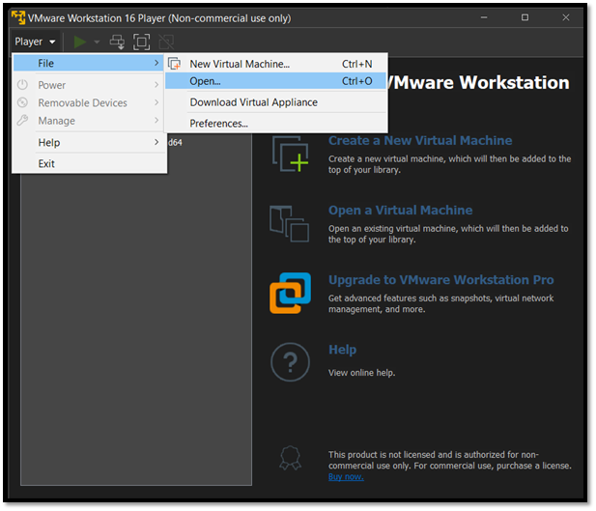

1. Start the VMware image by clicking the Play virtual machine button in the VMware Player if it is not already on.

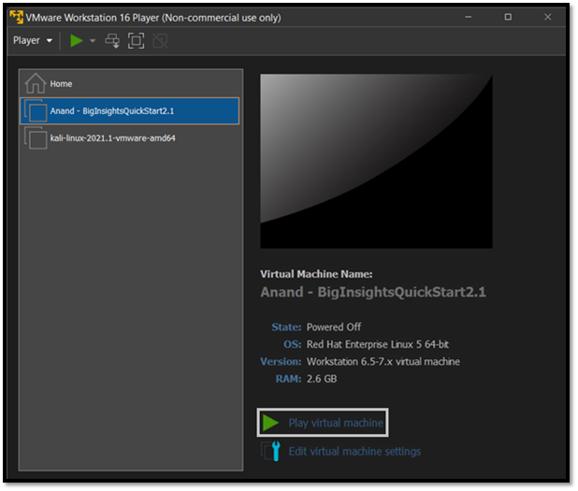

1. Log in to the VMware virtual machine using the following credentials.

Username: biadmin | Password: biadmin

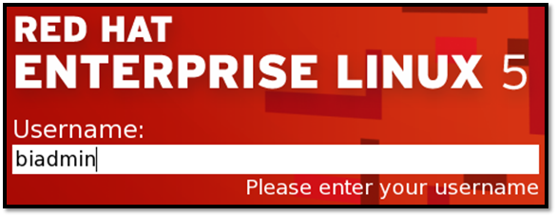

1. After you log in, your screen should look similar to the one below.

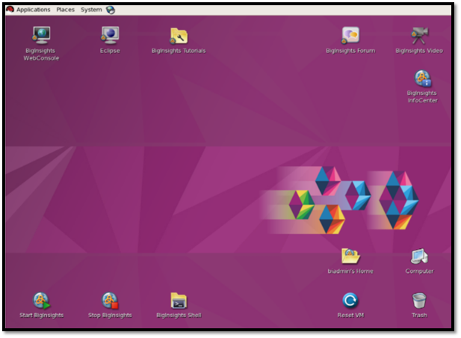

1. Double-clicking on the Start BigInsights icon would execute a script that would start all the components.



1. We can stop the components in a similar manner, by double-clicking on the Stop BigInsights icon.



**B.2 Input and Output:**

Using the command-line interface to explore the Hadoop Distributed File System:

The contents of the root directory are shown.

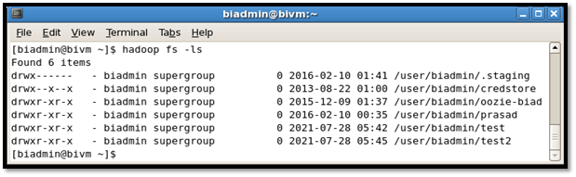

**B.3 Observations and learning:**

***(Students are expected to comment on the output obtained with clear observations and learning for each task/subpart assigned)***

The Hadoop Distributed File System (HDFS) allows users to arrange their data into files and directories. It has a command-line interface known as FS shell that allows users to interact with HDFS data that is available to Hadoop MapReduce applications.

**B.4 Conclusion:**

*(****Students must write the conclusion as per the attainment of individual outcome listed above and learning/observation noted in section B.3)***

Installed IBM Infosphere BigInsights successfully and explored HDFS on the Hadoop installation using Hadoop a command.

**B.5 Question of Curiosity**

***(To be answered by student based on the practical performed and learning/observations)***

## Q1: Which are the modes in which Hadoop can run?

**Ans:**

The three modes in which Hadoop can run are :

1. Standalone mode: This is the default mode. It uses the local FileSystem and a single Java process to run the Hadoop services.
2. Pseudo-distributed mode: This uses a single-node Hadoop deployment to execute all Hadoop services.
3. Fully distributed mode: This uses separate nodes to run Hadoop master and slave services.